The official Central Ordering System for the Ballarat FNL, Riddell DFNL and Maryborough Castlemaine District FNL

2019 Club Official Top Order Form – Ballarat FNL

DATE OF ORDER:
NAME OF CLUB/LEAGUE:
CONTACT PERSON:
ROLE AT CLUB/LEAGUE:
PHONE: | (B) | (H) | (M)
EMAIL:
DELIVERY ADDRESS (not a PO Box)
TOWN: |  | POSTCODE:
BILLING ADDRESS:
TOWN: |  | POSTCODE:

PRICING STRUCTURE
RUNNERS TOPS | RUNNERS SHORTS
$45.00 + GST | $35.00 + GST
WATER CARRIER TOPS | CLUB UMPIRE TOPS
$45.00 + GST | $45.00 + GST
MENTOR TOPS | TRAINER TOPS
$45.00 + GST | $45.00 + GST
GROUND MANAGER VESTS | UMPIRE ESCORT VESTS
$35.00 + GST | $35.00 + GST

Runners Tops | Runners Shorts | Water Carrier Tops | Club Umpire Tops
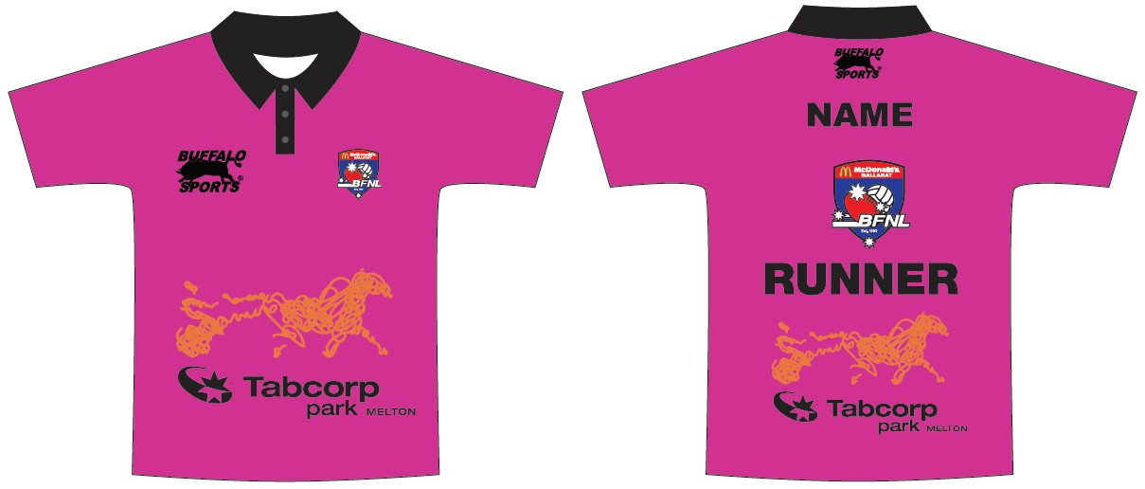 | 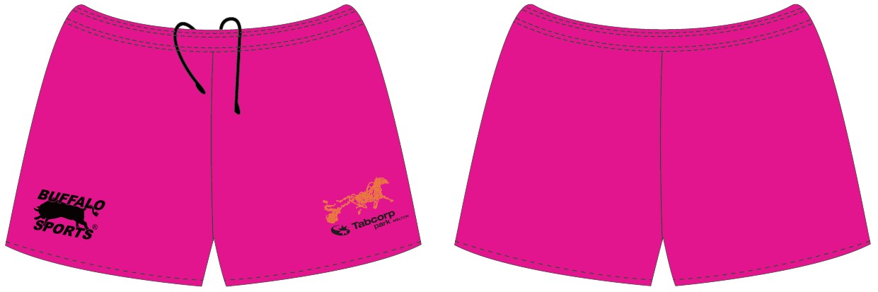 | 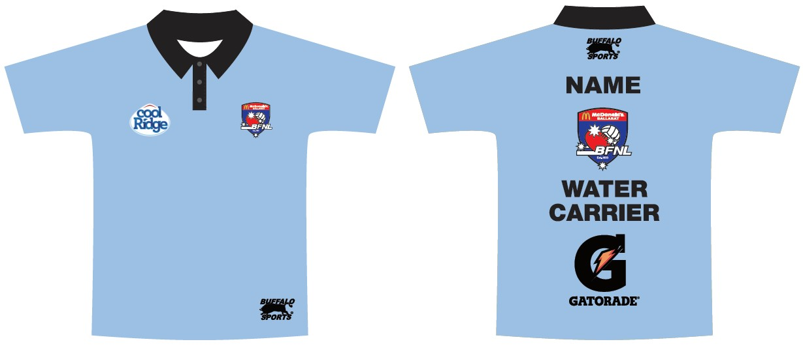 | 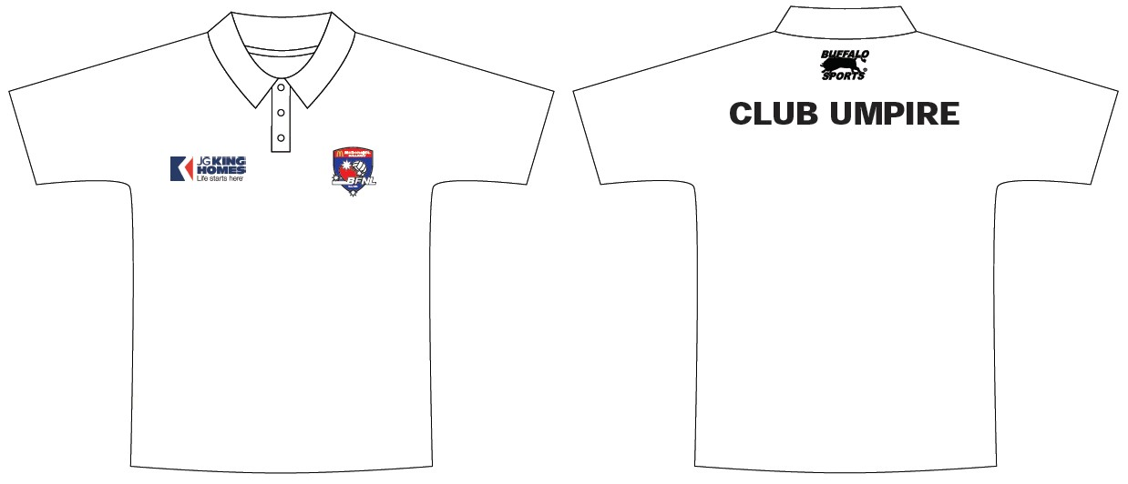
Mentor Tops | Ground Manager Vests | Umpire Escort Vests | Trainers Tops
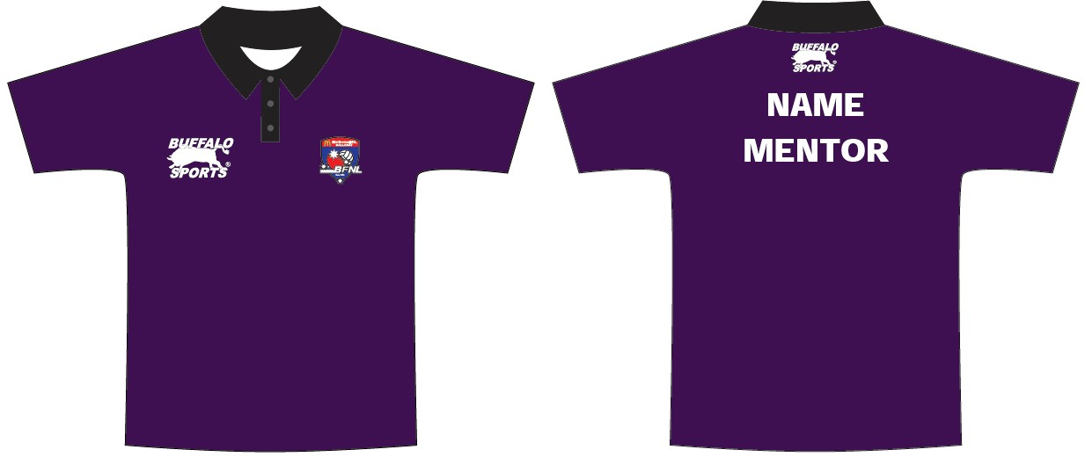 | 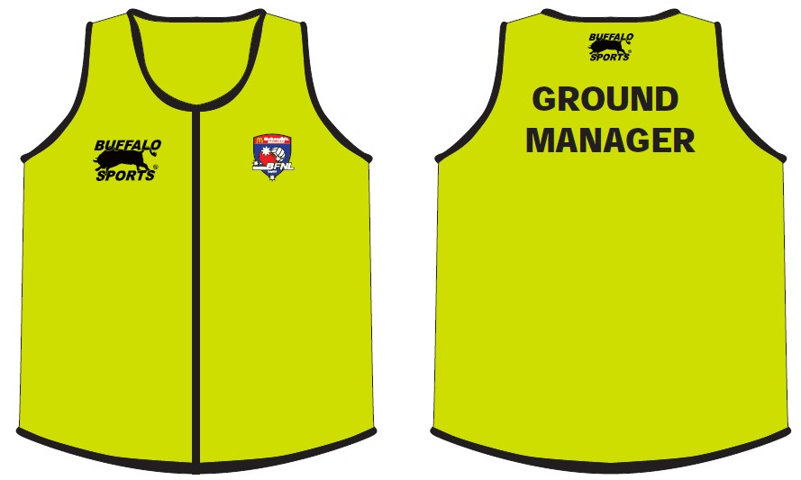 | 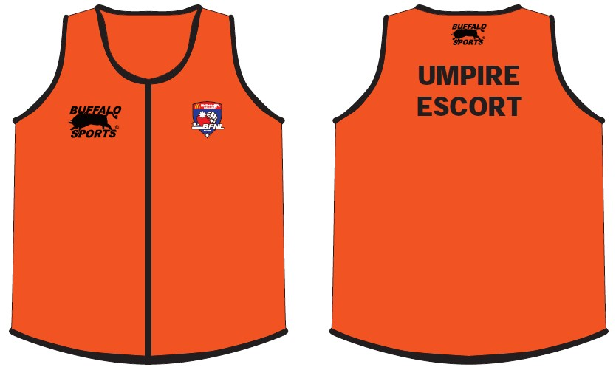 | 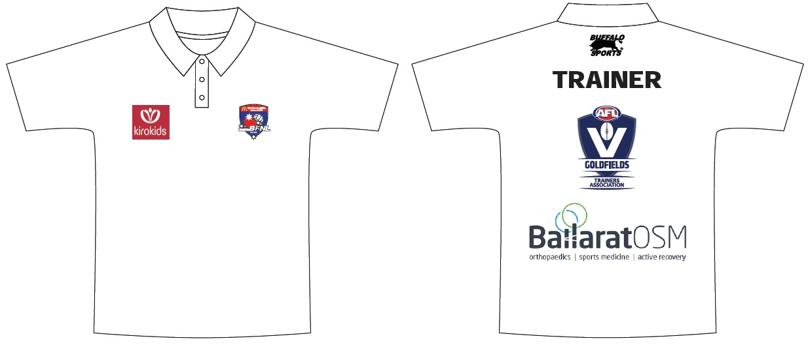

Top: | Colour: | Price: | XS  51cm | S  53cm | M  55cm | L  57cm | XL  59cm | 2XL  61cm | 3XL  63cm | 4XL  65cm | 5XL  67cm | Total:
CLUB NAME ON TOPS:
Club Runner  Tops | Pink | $40.00
Runners  Shorts | Pink | $30.00
Water Carrier  Tops | Light Blue | $40.00
Mentor Tops | Purple | $40.00
Club Volunteer  Umpire Tops | White | $40.00
Trainers Tops | White | $40.00
Ground Manager  Vests | Yellow | $30.00
Umpire Escort  Vests | Orange | $30.00

Price (excl. GST): _______________

Delivery (excl. GST): _____$20.00_____

GST: _______________

TOTAL: _______________

Terms & Conditions:
- Cheque, EFT or credit card are the payment methods available - 2% surcharge applies to credit card payments.
- A Tax Invoice will be provided at the time of order acceptance.
- Payment is due 30 days from delivery of goods.
- Standard delivery fees per supplier as follows (+GST): - $20.00.
- Delivery times of 6-8 weeks from finalisation of order - all design and logo requirements to be signed off first.

